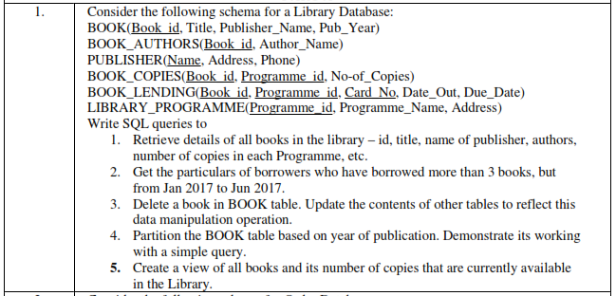

**CREATE TABLE BOOK**

**(**

**BOOK_ID INT,**

**TITLE VARCHAR(20),**

**PUB_YEAR VARCHAR(20),**

**PUBLISHER_NAME VARCHAR(20),**

**PRIMARY KEY (BOOK_ID)**

**);**

**CREATE TABLE AUTHORS**

**(**

**BOOK_ID INT,**

**AUTHOR_NAME VARCHAR(20),**

**PRIMARY KEY (BOOK_ID),**

**FOREIGN KEY (BOOK_ID) REFERENCES BOOK (BOOK_ID) ON DELETE CASCADE**

**);**

**CREATE TABLE PUBLISHER**

**(**

**NAME VARCHAR(20),**

**ADDRESS VARCHAR(20),**

**PHONE_NO VARCHAR(11),**

**PRIMARY KEY (NAME)**

**);**

**ALTER TABLE BOOK ADD FOREIGN KEY (PUBLISHER_NAME) REFERENCES PUBLISHER (NAME);**

**CREATE TABLE BOOK_COPIES**

**(**

**BOOK_ID INT,**

**PROGRAMME_ID INT,**

**NO_OF_COPIES INT,**

**PRIMARY KEY (BOOK_ID, PROGRAMME_ID),**

**FOREIGN KEY (BOOK_ID) REFERENCES BOOK (BOOK_ID) ON DELETE CASCADE**

**);**

**CREATE TABLE CARD**

**(**

**CARD_NO INT,**

**PRIMARY KEY (CARD_NO)**

**);**

**CREATE TABLE BOOK_LENDING**

**(**

**BOOK_ID INT,**

**PROGRAMME_ID INT,**

**CARD_NO INT,**

**DATE_OUT DATE,**

**DUE_DATE DATE,**

**PRIMARY KEY (BOOK_ID, PROGRAMME_ID, CARD_NO),**

**FOREIGN KEY (BOOK_ID) REFERENCES BOOK (BOOK_ID) ON DELETE CASCADE**

**);**

**CREATE TABLE LIBRARY_PROGRAMME**

**(**

**PROGRAMME_ID INT,**

**PROGRAMME_NAME VARCHAR(20),**

**ADDRESS VARCHAR(20),**

**PRIMARY KEY (PROGRAMME_ID)**

**);**

**ALTER TABLE BOOK_COPIES ADD FOREIGN KEY (PROGRAMME_ID) REFERENCES LIBRARY_PROGRAMME (PROGRAMME_ID) ON DELETE CASCADE;**

**ALTER TABLE BOOK_LENDING ADD FOREIGN KEY (PROGRAMME_ID) REFERENCES LIBRARY_PROGRAMME (PROGRAMME_ID) ON DELETE CASCADE;**

**ALTER TABLE BOOK_LENDING ADD FOREIGN KEY (CARD_NO) REFERENCES CARD (CARD_NO) ON DELETE CASCADE;**

**INSERT INTO BOOK VALUES ('1', 'DBMS', 'JAN-2017', NULL);**

**INSERT INTO BOOK VALUES ('2', 'ADBMS', 'JUN-2016', NULL);**

**INSERT INTO BOOK VALUES ('3', 'CD', 'SEP-2016', NULL);**

**INSERT INTO BOOK VALUES ('4', 'ALGORITHMS', 'SEP-2015', NULL);**

**INSERT INTO BOOK VALUES ('5', 'OS', 'MAY-2016', NULL);**

**INSERT INTO AUTHORS VALUES ('1', 'NAVATHE');**

**INSERT INTO AUTHORS VALUES ('2', 'NAVATHE');**

**INSERT INTO AUTHORS VALUES ('3', 'ULLMAN');**

**INSERT INTO AUTHORS VALUES ('4', 'CHARLES');**

**INSERT INTO AUTHORS VALUES ('5', 'GALVIN');**

**INSERT INTO PUBLISHER VALUES ('MCGRAW-HILL', 'BANGALORE', '9889012341');**

**INSERT INTO PUBLISHER VALUES ('PEARSON', 'NEW DELHI', '9889012342');**

**INSERT INTO PUBLISHER VALUES ('PRENTICE HALL', 'HYDREBAD', '9889012343');**

**INSERT INTO PUBLISHER VALUES ('WILEY', 'CHENNAI', '9889012344');**

**INSERT INTO PUBLISHER VALUES ('MIT', 'BANGALORE', '9889012345');**

**INSERT INTO LIBRARY_PROGRAMME VALUES ('10', 'VIJAY NAGAR', 'MYSURU');**

**INSERT INTO LIBRARY_PROGRAMME VALUES ('11', 'VIDYA NAGAR', 'HUBLI');**

**INSERT INTO LIBRARY_PROGRAMME VALUES ('12', 'KUVEMPU NAGAR', 'MYSURU');**

**INSERT INTO LIBRARY_PROGRAMME VALUES ('13', 'RAJAJI NAGAR', 'MYSURU');**

**INSERT INTO LIBRARY_PROGRAMME VALUES ('14', 'MANIPAL', 'UDUPI');**

**INSERT INTO BOOK_COPIES VALUES ('1', '10', '10');**

**INSERT INTO BOOK_COPIES VALUES ('1', '11', '5');**

**INSERT INTO BOOK_COPIES VALUES ('2', '12', '2');**

**INSERT INTO BOOK_COPIES VALUES ('2', '13', '5');**

**INSERT INTO BOOK_COPIES VALUES ('3', '14', '7');**

**INSERT INTO BOOK_COPIES VALUES ('5', '10', '1');**

**INSERT INTO BOOK_COPIES VALUES ('4', '11', '3');**

**INSERT INTO CARD VALUES ('100');**

**INSERT INTO CARD VALUES ('101');**

**INSERT INTO CARD VALUES ('102');**

**INSERT INTO CARD VALUES ('103');**

**INSERT INTO CARD VALUES ('104');**

**INSERT INTO BOOK_LENDING VALUES ('1', '10', '101', '01-JAN-2017', '01-JUN-2017');**

**INSERT INTO BOOK_LENDING VALUES ('1', '11', '101', '12-APR-2017', '12-MAY-2017');**

**INSERT INTO BOOK_LENDING VALUES ('2', '13', '101', '21-FEB-2017', '21-APR-2017');**

**INSERT INTO BOOK_LENDING VALUES ('3', '14', '101', '11-JAN-2017', '11-MAR-2017');**

**INSERT INTO BOOK_LENDING VALUES ('4', '11', '101', '15-MAR-2017', '15-JUL-2017');**

**UPDATE BOOK**

**SET PUBLISHER_NAME = 'MCGRAW-HILL'**

**WHERE BOOK_ID = '1';**

**UPDATE BOOK**

**SET PUBLISHER_NAME = 'MCGRAW-HILL'**

**WHERE BOOK_ID = '2';**

**UPDATE BOOK**

**SET PUBLISHER_NAME = 'PEARSON'**

**WHERE BOOK_ID = '3';**

**UPDATE BOOK**

**SET PUBLISHER_NAME = 'MIT'**

**WHERE BOOK_ID = '4';**

**UPDATE BOOK**

**SET PUBLISHER_NAME = 'PEARSON'**

**WHERE BOOK_ID = '5';**

**SELECT A.AUTHOR_NAME, B.BOOK_ID, B.PUBLISHER_NAME, B.TITLE, C.NO_OF_COPIES, L.PROGRAMME_ID**

**FROM AUTHORS A, BOOK B, BOOK_COPIES C, LIBRARY_PROGRAMME L**

**WHERE B.BOOK_ID = A.BOOK_ID AND B.BOOK_ID = C.BOOK_ID AND C.PROGRAMME_ID = L.PROGRAMME_ID;**

**SELECT CARD_NO**

**FROM BOOK_LENDING**

**WHERE DATE_OUT BETWEEN '01-JAN-2017' AND '01-JUL-2017'**

**GROUP BY CARD_NO**

**HAVING COUNT(*) > 3;**

**DELETE FROM BOOK WHERE BOOK_ID = '3';**

**CREATE VIEW VW_PUBLICATIONS AS**

**SELECT PUB_YEAR**

**FROM BOOK;**

**CREATE VIEW VW_BOOKS AS**

**SELECT B.BOOK_ID, B.TITLE, C.NO_OF_COPIES**

**FROM BOOK B, BOOK_COPIES C, LIBRARY_PROGRAMME L**

**WHERE B.BOOK_ID = C.BOOK_ID AND C.PROGRAMME_ID = L.PROGRAMME_ID;**

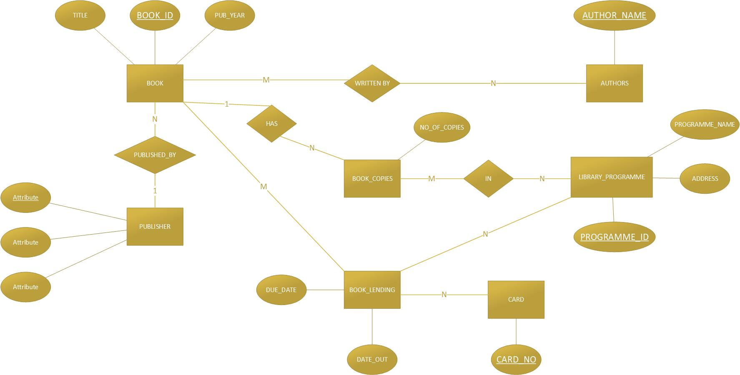

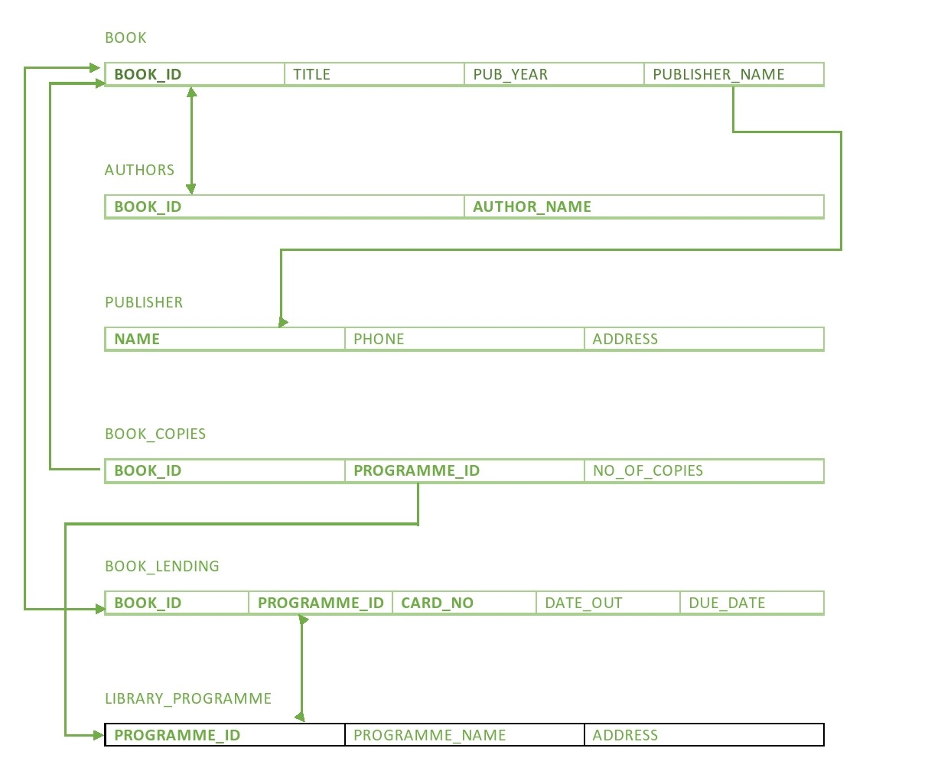

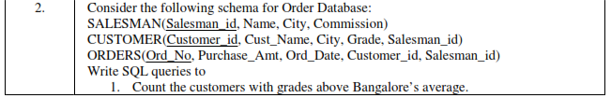

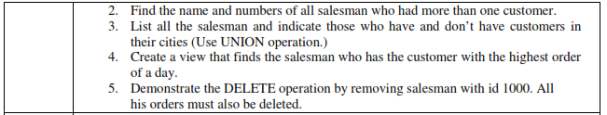

**CREATE TABLE SALESMAN**

**(**

**SALESMAN_ID INT,**

**NAME VARCHAR(20),**

**CITY VARCHAR(20),**

**COMMISSION VARCHAR(20),**

**PRIMARY KEY (SALESMAN_ID)**

**);**

**CREATE TABLE CUSTOMER**

**(**

**CUSTOMER_ID INT,**

**CUST_NAME VARCHAR(20),**

**CITY VARCHAR(20),**

**GRADE INT,**

**SALESMAN_ID INT,**

**PRIMARY KEY (CUSTOMER_ID),**

**FOREIGN KEY (SALESMAN_ID) REFERENCES SALESMAN (SALESMAN_ID) ON DELETE SET NULL**

**);**

**CREATE TABLE ORDERS**

**(**

**ORD_ID INT,**

**PURCHASE_AMT DECIMAL(10,2),**

**ORD_DATE DATE,**

**CUSTOMER_ID INT,**

**SALESMAN_ID INT,**

**PRIMARY KEY (ORD_ID),**

**FOREIGN KEY (SALESMAN_ID) REFERENCES SALESMAN (SALESMAN_ID) ON DELETE CASCADE,**

**FOREIGN KEY (CUSTOMER_ID) REFERENCES CUSTOMER (CUSTOMER_ID) ON DELETE CASCADE**

**);**

**INSERT INTO SALESMAN VALUES ('101', 'RAM', 'DELHI', '18%');**

**INSERT INTO SALESMAN VALUES ('103', 'BOBBY', 'NOIDA', '36%');**

**INSERT INTO SALESMAN VALUES ('110', 'CHINTU', 'BANGALORE', '54%');**

**INSERT INTO SALESMAN VALUES ('122', 'DEEPAK', 'PUNE', '36%');**

**INSERT INTO SALESMAN VALUES ('126', 'EKTA', 'MANGALORE', '18%');**

**INSERT INTO SALESMAN VALUES ('132', 'FATIMA', 'CHENNAI', '18%');**

**INSERT INTO CUSTOMER VALUES ('501', 'AMITABH', 'DELHI', '10', '103');**

**INSERT INTO CUSTOMER VALUES ('510', 'KARAN', 'JAIPUR', '14', '122');**

**INSERT INTO CUSTOMER VALUES ('522', 'SINTU', 'BANGALORE', '10', '132');**

**INSERT INTO CUSTOMER VALUES ('534', 'VISHAL', 'VELLORE', '17', '103');**

**INSERT INTO CUSTOMER VALUES ('543', 'MOHAN', 'BANGALORE', '14', '110');**

**INSERT INTO CUSTOMER VALUES ('550', 'PANKAJ', 'JAIPUR', '19', '126');**

**INSERT INTO ORDERS VALUES ('1', '1000', '04-MAY-2017', '501', '103');**

**INSERT INTO ORDERS VALUES ('2', '4000', '20-JAN-2017', '522', '132');**

**INSERT INTO ORDERS VALUES ('3', '250', '24-FEB-2017', '550', '126');**

**INSERT INTO ORDERS VALUES ('5', '6000', '13-APR-2017', '522', '103');**

**INSERT INTO ORDERS VALUES ('6', '7000', '09-MAR-2017', '550', '126');**

**INSERT INTO ORDERS VALUES ('7', '3400', '20-JAN-2017', '501', '122');**

**SELECT GRADE, COUNT (CUSTOMER_ID)**

**FROM CUSTOMER**

**GROUP BY GRADE**

**HAVING GRADE >**

**( SELECT AVG (GRADE)**

**FROM CUSTOMER**

**WHERE CITY = 'BANGALORE');**

**SELECT SALESMAN_ID, NAME**

**FROM SALESMAN**

**WHERE SALESMAN_ID IN**

**( SELECT SALESMAN_ID**

**FROM CUSTOMER**

**GROUP BY SALESMAN_ID**

**HAVING COUNT(CUSTOMER_ID) > 1);**

**SELECT S.SALESMAN_ID, NAME, C.CUST_NAME, COMMISSION**

**FROM SALESMAN S, CUSTOMER C**

**WHERE S.CITY = C.CITY**

**UNION**

**SELECT SALESMAN_ID, NAME, 'NO MATCH', COMMISSION**

**FROM SALESMAN**

**WHERE NOT CITY = ANY**

**(SELECT CITY**

**FROM CUSTOMER)**

**ORDER BY 2 DESC;**

**CREATE VIEW VW_ELITE_SALESMAN AS**

**SELECT A.SALESMAN_ID, A.NAME, B.ORD_DATE**

**FROM SALESMAN A, ORDERS B**

**WHERE A.SALESMAN_ID = B.SALESMAN_ID AND B.PURCHASE_AMT = (SELECT MAX(PURCHASE_AMT)**

**FROM ORDERS C**

**WHERE C.ORD_DATE = B.ORD_DATE);**

**DELETE FROM SALESMAN WHERE SALESMAN_ID = '110';**

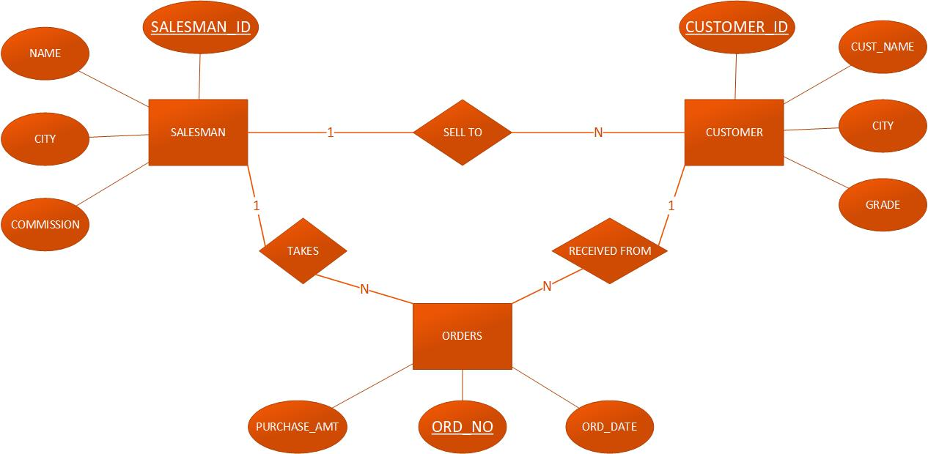

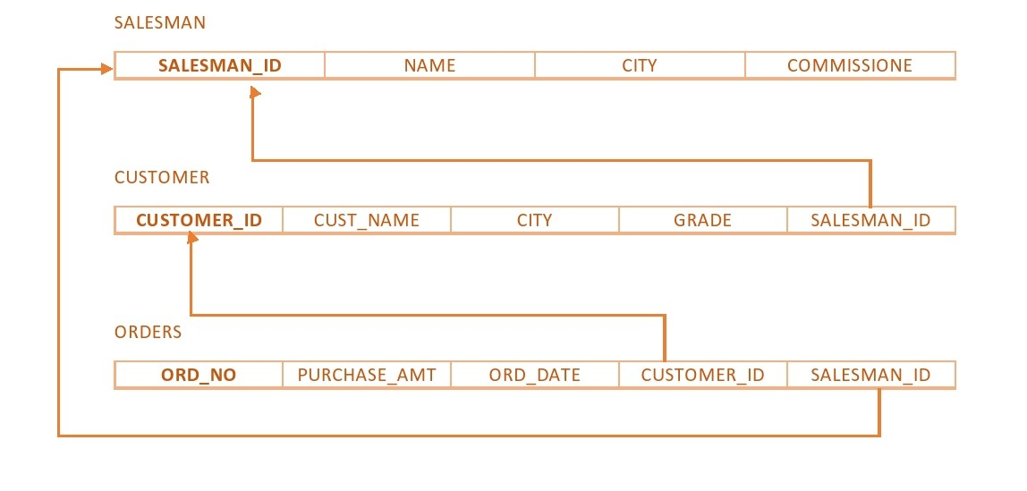

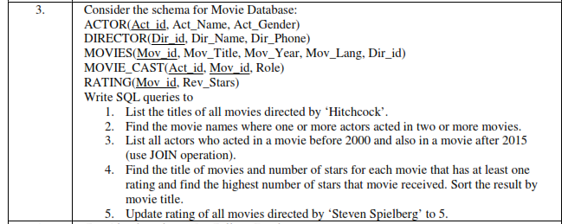

**CREATE TABLE ACTOR**

**(**

**ACT_ID INT,**

**ACT_NAME VARCHAR(20),**

**ACT_GENDER CHAR,**

**PRIMARY KEY (ACT_ID)**

**);**

**CREATE TABLE DIRECTOR**

**(**

**DIR_ID INT,**

**DIR_NAME VARCHAR(20),**

**DIR_PHONE CHAR(10),**

**PRIMARY KEY (DIR_ID)**

**);**

**CREATE TABLE MOVIES**

**(**

**MOV_ID INT,**

**MOV_TITLE VARCHAR(50),**

**MOV_YEAR INT,**

**MOV_LANG VARCHAR(20),**

**DIR_ID INT,**

**PRIMARY KEY (MOV_ID)**

**);**

**CREATE TABLE MOVIE_CAST**

**(**

**ACT_ID INT,**

**MOV_ID INT,**

**ROLE VARCHAR(20),**

**PRIMARY KEY (ACT_ID, MOV_ID)**

**);**

**CREATE TABLE RATING**

**(**

**MOV_ID INT,**

**REV_STARS VARCHAR(20),**

**PRIMARY KEY (MOV_ID)**

**);**

**INSERT INTO ACTOR VALUES ('1', 'MADHURI DIXIT', 'F');**

**INSERT INTO ACTOR VALUES ('2', 'AKSHAY KUMAR', 'M');**

**INSERT INTO ACTOR VALUES ('3', 'JUHI CHAWLA', 'F');**

**INSERT INTO ACTOR VALUES ('4', 'MADHURI DIXIT', 'M');**

**INSERT INTO DIRECTOR VALUES ('100', 'SUBHASH KAPOOR', '9880912341');**

**INSERT INTO DIRECTOR VALUES ('102', 'ALAN TAYLOR', '9880912342');**

**INSERT INTO DIRECTOR VALUES ('103', 'SANTHOSH KUMAR', '9880912343');**

**INSERT INTO DIRECTOR VALUES ('104', 'IMTIAZ ALI', '9880912344');**

**INSERT INTO DIRECTOR VALUES ('105', 'HITCHCOCK', '9880912345');**

**INSERT INTO DIRECTOR VALUES ('106', 'STEVEN SPIELBERG', '9880912346');**

**INSERT INTO MOVIES VALUES('501', 'JAB HARRY MET SEJAL', '2017', 'HINDI', '104');**

**INSERT INTO MOVIES VALUES('502', 'RAJAKUMAR', '2017', 'KANNADA', '103');**

**INSERT INTO MOVIES VALUES('503', 'JOLLY LLB', '2013', 'HINDI', '100');**

**INSERT INTO MOVIES VALUES('504', 'TERMINATOR', '2015', 'ENGLISH', '102');**

**INSERT INTO MOVIES VALUES('505', 'JAWS', '1975', 'ENGLISH', '106');**

**INSERT INTO MOVIES VALUES('506', 'BRIDGE OF SPIES', '2015', 'ENGLSIH', '106');**

**INSERT INTO MOVIES VALUES('507', 'GRAVITY', '1943', 'ENGLISH', '105');**

**INSERT INTO MOVIES VALUES('508', 'SHADOW OF A DOUBT', '1943', 'ENGLISH', '105');**

**INSERT INTO MOVIE_CAST VALUES ('1', '501', 'HEROINE');**

**INSERT INTO MOVIE_CAST VALUES ('1', '502', 'HEROINE');**

**INSERT INTO MOVIE_CAST VALUES ('3', '503', 'COMEDIAN');**

**INSERT INTO MOVIE_CAST VALUES ('4', '504', 'GUEST');**

**INSERT INTO MOVIE_CAST VALUES ('4', '501', 'HERO');**

**INSERT INTO RATING VALUES ('501', '4');**

**INSERT INTO RATING VALUES ('502', '2');**

**INSERT INTO RATING VALUES ('503', '5');**

**INSERT INTO RATING VALUES ('504', '4');**

**INSERT INTO RATING VALUES ('505', '3');**

**INSERT INTO RATING VALUES ('506', '2');**

**ALTER TABLE MOVIES ADD FOREIGN KEY (DIR_ID) REFERENCES DIRECTOR (DIR_ID);**

**ALTER TABLE MOVIE_CAST ADD FOREIGN KEY (ACT_ID) REFERENCES ACTOR (ACT_ID);**

**ALTER TABLE MOVIE_CAST ADD FOREIGN KEY (MOV_ID) REFERENCES MOVIES (MOV_ID);**

**ALTER TABLE RATING ADD FOREIGN KEY (MOV_ID) REFERENCES MOVIES (MOV_ID);**

**SELECT M.MOV_TITLE**

**FROM MOVIES M, DIRECTOR D**

**WHERE D.DIR_ID = M.DIR_ID AND D.DIR_NAME = 'HITCHCOCK';**

**SELECT MOV_TITLE**

**FROM MOVIES M, MOVIE_CAST MV**

**WHERE MV.MOV_ID = M.MOV_ID AND ACT_ID IN**

**(**

**SELECT ACT_ID**

**FROM MOVIE_CAST**

**GROUP BY ACT_ID**

**HAVING COUNT (ACT_ID) > 1**

**)**

**GROUP BY MOV_TITLE**

**HAVING COUNT(*) > 1;**

**SELECT ACT_NAME, MOV_TITLE, MOV_YEAR**

**FROM ACTOR A**

**JOIN MOVIE_CAST MV**

**ON A.ACT_ID = MV.ACT_ID**

**JOIN MOVIES M**

**ON M.MOV_ID = MV.MOV_ID**

**WHERE M.MOV_YEAR NOT BETWEEN '2000' AND '2015';**

**SELECT MOV_TITLE, MAX (REV_STARS)**

**FROM MOVIES M, RATING R**

**WHERE M.MOV_ID = R.MOV_ID**

**GROUP BY MOV_TITLE**

**HAVING MAX (REV_STARS) > 0**

**ORDER BY MOV_TITLE;**

**UPDATE RATING**

**SET REV_STARS = '5'**

**WHERE MOV_ID IN**

**(**

**SELECT MOV_ID**

**FROM MOVIES**

**WHERE DIR_ID IN**

**(**

**SELECT DIR_ID**

**FROM DIRECTOR**

**WHERE DIR_NAME = 'STEVEN SPIELBERG'**

**)**

**);**

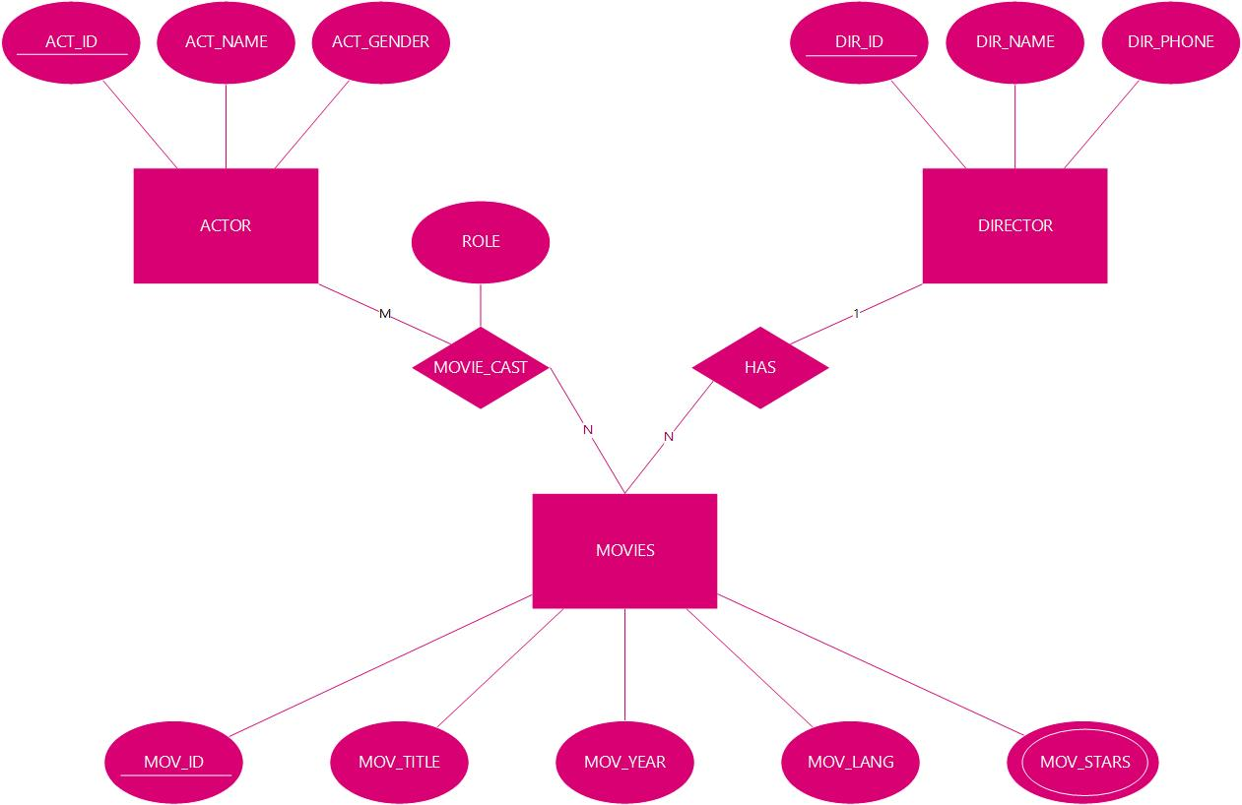

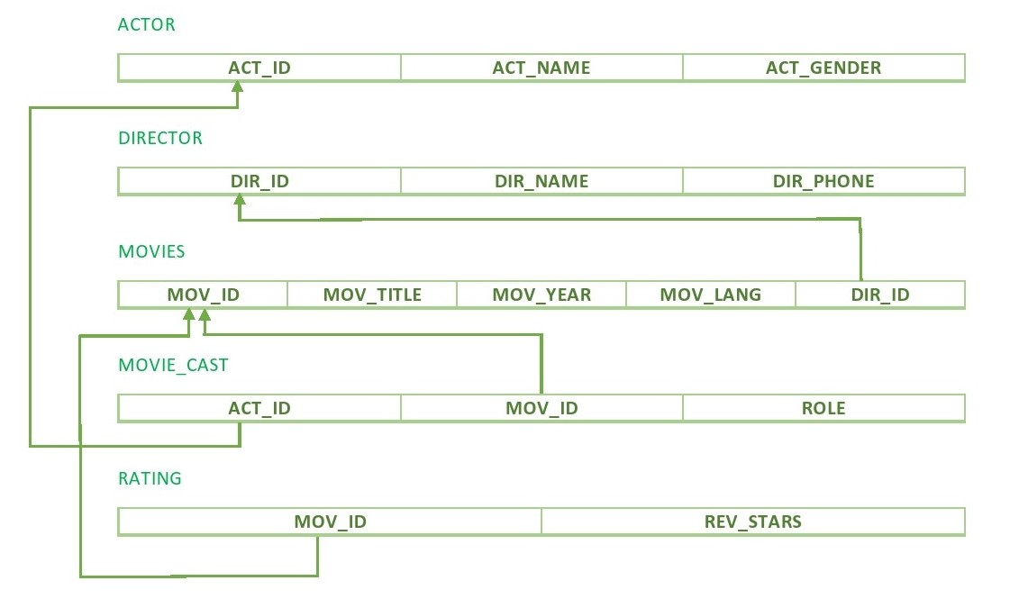

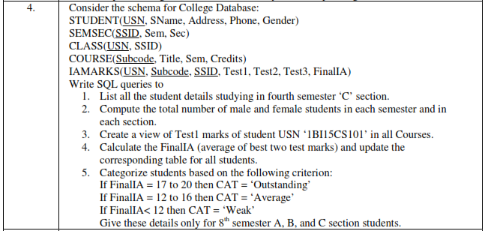

**CREATE TABLE STUDENT**

**(**

**USN VARCHAR(10),**

**SNAME VARCHAR(20),**

**ADDRESS VARCHAR(30),**

**PHONE VARCHAR(10),**

**GENDER CHAR,**

**PRIMARY KEY (USN)**

**);**

**CREATE TABLE SEMSEC**

**(**

**SSID VARCHAR(5),**

**SEM CHAR,**

**SEC CHAR,**

**PRIMARY KEY (SSID)**

**);**

**CREATE TABLE CLASS**

**(**

**USN VARCHAR(10),**

**SSID VARCHAR(5),**

**PRIMARY KEY (USN, SSID),**

**FOREIGN KEY (USN) REFERENCES STUDENT (USN),**

**FOREIGN KEY (SSID) REFERENCES SEMSEC (SSID)**

**);**

**CREATE TABLE SUBJECT**

**(**

**SUBCODE VARCHAR(7),**

**TITLE VARCHAR(20),**

**SEM CHAR,**

**CREDITS CHAR,**

**PRIMARY KEY (SUBCODE)**

**);**

**CREATE TABLE IAMARKS**

**(**

**USN VARCHAR(10),**

**SUBCODE VARCHAR(7),**

**SSID VARCHAR(5),**

**TEST1 INT,**

**TEST2 INT,**

**TEST3 INT,**

**FINALIA INT,**

**PRIMARY KEY (USN, SUBCODE, SSID),**

**FOREIGN KEY (SUBCODE) REFERENCES SUBJECT (SUBCODE),**

**FOREIGN KEY (SSID) REFERENCES SEMSEC (SSID)**

**);**

**INSERT INTO STUDENT VALUES ('1VA12CS001', 'ANWAR', 'BANGALORE', '9845612341', 'M');**

**INSERT INTO STUDENT VALUES ('1VA12CS002', 'BHARAT', 'BANGALORE', '9845612342', 'M');**

**INSERT INTO STUDENT VALUES ('1VA12CS003', 'CHITRA', 'HUBLI', '9845612343', 'F');**

**INSERT INTO STUDENT VALUES ('1VA13CS004', 'DANIEL', 'BANGALORE', '9845612344', 'M');**

**INSERT INTO STUDENT VALUES ('1BI15CS101', 'RAJESH', 'PUNE', '9845612345', 'M');**

**INSERT INTO STUDENT VALUES ('1BI15CS102', 'GAYATRI', 'BANGALORE', '9845612346', 'F');**

**INSERT INTO SEMSEC VALUES ('S1', '4', 'C');**

**INSERT INTO SEMSEC VALUES ('S2', '8', 'A');**

**INSERT INTO SEMSEC VALUES ('S3', '8', 'B');**

**INSERT INTO SEMSEC VALUES ('S4', '8', 'C');**

**INSERT INTO SEMSEC VALUES ('S5', '5', 'A');**

**INSERT INTO SEMSEC VALUES ('S6', '5', 'B');**

**INSERT INTO SEMSEC VALUES ('S7', '4', 'B');**

**INSERT INTO SEMSEC VALUES ('S8', '4', 'A');**

**INSERT INTO CLASS VALUES ('1BI15CS101', 'S5');**

**INSERT INTO CLASS VALUES ('1BI15CS102', 'S3');**

**INSERT INTO CLASS VALUES ('1VA12CS001', 'S1');**

**INSERT INTO CLASS VALUES ('1VA12CS002', 'S2');**

**INSERT INTO CLASS VALUES ('1VA12CS003', 'S3');**

**INSERT INTO CLASS VALUES ('1VA13CS004', 'S4');**

**INSERT INTO SUBJECT VALUES ('10CS51', 'ME', '5', '4');**

**INSERT INTO SUBJECT VALUES ('10CS52', 'DBMS', '5', '4');**

**INSERT INTO SUBJECT VALUES ('10CS81', 'ACA', '8', '3');**

**INSERT INTO SUBJECT VALUES ('10CS82', 'NM', '8', '3');**

**INSERT INTO SUBJECT VALUES ('10CS83', 'DOS', '8', '3');**

**INSERT INTO SUBJECT VALUES ('10CS41', 'ADA', '4', '4');**

**INSERT INTO SUBJECT VALUES ('10CS42', 'C++', '4', '4');**

**INSERT INTO IAMARKS VALUES ('1BI15CS101', '10CS51', 'S5', '19', '12', '20', '0');**

**INSERT INTO IAMARKS VALUES ('1BI15CS101', '10CS52', 'S5', '13', '14', '22', '0');**

**INSERT INTO IAMARKS VALUES ('1VA12CS002', '10CS81', 'S2', '12', '14', '24', '0');**

**INSERT INTO IAMARKS VALUES ('1VA12CS002', '10CS82', 'S2', '13', '11', '20', '0');**

**INSERT INTO IAMARKS VALUES ('1VA12CS002', '10CS83', 'S2', '12', '16', '12', '0');**

**SELECT S.*, SS.SEM, SS.SEC**

**FROM STUDENT S, SEMSEC SS, CLASS C**

**WHERE S.USN = C.USN AND SS.SSID = C.SSID AND SS.SEM = '4' AND SS.SEC = 'C';**

**SELECT SS.SEM, SS.SEC, S.GENDER, COUNT(S.GENDER) COUNT**

**FROM STUDENT S, SEMSEC SS, CLASS C**

**WHERE S.USN = C.USN AND SS.SSID = C.SSID**

**GROUP BY SS.SEM, SS.SEC, S.GENDER**

**ORDER BY SEM;**

**CREATE VIEW VW_STUDENT_MARKS AS**

**SELECT TEST1, SUBCODE**

**FROM IAMARKS**

**WHERE USN = '1BI15CS101';**

**UPDATE IAMARKS**

**SET FINALIA = GREATEST (TEST1 + TEST2, TEST2 + TEST3, TEST3 + TEST1)/2;**

**SELECT S.USN, S.SNAME, S.ADDRESS, S.PHONE, S.GENDER,**

**(**

**CASE**

**WHEN IA.FINALIA BETWEEN '17' AND '20' THEN 'OUTSTANDING'**

**WHEN IA.FINALIA BETWEEN '12' AND '16' THEN 'AVERAGE'**

**ELSE 'WEAK'**

**END)**

**AS CAT**

**FROM STUDENT S, SEMSEC SS, IAMARKS IA, SUBJECT SUB**

**WHERE S.USN = IA.USN AND SS.SSID = IA.SSID AND SUB.SUBCODE = IA.SUBCODE AND SUB.SEM = '8';**

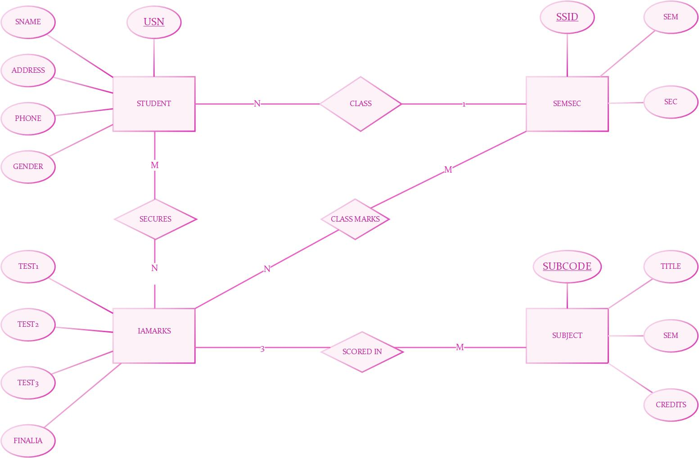

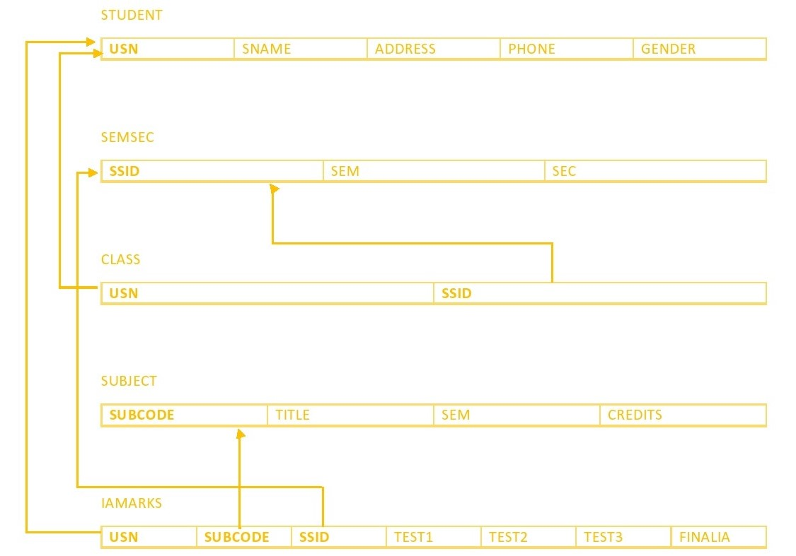

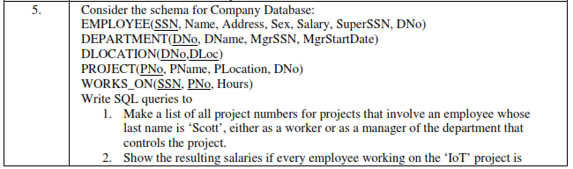

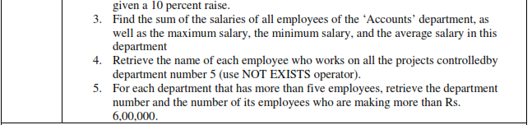

**CREATE TABLE EMPLOYEE**

**(**

**SSN VARCHAR(9),**

**FNAME VARCHAR(20),**

**LNAME VARCHAR(20),**

**ADDRESS VARCHAR(50),**

**SEX CHAR,**

**SALARY DECIMAL(10,2),**

**SUPER_SSN VARCHAR(9),**

**DNO INT,**

**PRIMARY KEY (SSN),**

**FOREIGN KEY (SUPER_SSN) REFERENCES EMPLOYEE (SSN)**

**);**

**CREATE TABLE DEPARTMENT**

**(**

**DNO INT,**

**DNAME VARCHAR(20),**

**MGR_SSN VARCHAR(9),**

**MGR_START_DATE DATE,**

**PRIMARY KEY (DNO),**

**FOREIGN KEY (MGR_SSN) REFERENCES EMPLOYEE (SSN)**

**);**

**ALTER TABLE EMPLOYEE ADD FOREIGN KEY (DNO) REFERENCES DEPARTMENT (DNO);**

**CREATE TABLE DLOCATION**

**(**

**DNO INT,**

**DLOC VARCHAR(50),**

**PRIMARY KEY (DNO, DLOC),**

**FOREIGN KEY (DNO) REFERENCES DEPARTMENT (DNO)**

**);**

**CREATE TABLE PROJECT**

**(**

**PNO INT,**

**PNAME VARCHAR(20),**

**PLOCATION VARCHAR(50),**

**DNO INT,**

**PRIMARY KEY (PNO),**

**FOREIGN KEY (DNO) REFERENCES DEPARTMENT (DNO)**

**);**

**CREATE TABLE WORKS_ON**

**(**

**SSN VARCHAR(9),**

**PNO INT,**

**HOURS DECIMAL(3,1),**

**PRIMARY KEY (SSN, PNO),**

**FOREIGN KEY (PNO) REFERENCES PROJECT (PNO),**

**FOREIGN KEY (SSN) REFERENCES EMPLOYEE (SSN)**

**);**

**INSERT INTO EMPLOYEE VALUES ('ABCDACC01', 'AHANA', 'K', 'MANGALORE', 'F', '350000', NULL, NULL);**

**INSERT INTO EMPLOYEE VALUES ('ABCDACC02', 'SANTOSH', 'KUMAR', 'MANGALORE', 'M', '300000', NULL, NULL);**

**INSERT INTO EMPLOYEE VALUES ('ABCDCSE01', 'JAMES', 'SMITH', 'BANGALORE', 'M', '500000', NULL, NULL);**

**INSERT INTO EMPLOYEE VALUES ('ABCDCSE02', 'HEARNS', 'BAKER', 'BANGALORE', 'M', '700000', NULL, NULL);**

**INSERT INTO EMPLOYEE VALUES ('ABCDCSE03', 'EDWARD', 'SCOTT', 'MYSORE', 'M', '500000', NULL, NULL);**

**INSERT INTO EMPLOYEE VALUES ('ABCDECE01', 'JOHN', 'SCOTT', 'BANGALORE', 'M', '500000', NULL, NULL);**

**INSERT INTO EMPLOYEE VALUES ('ABCDIT01', 'NAGESH', 'HR', 'BANGALORE', 'F', '500000', NULL, NULL);**

**INSERT INTO DEPARTMENT VALUES ('1', 'ACCOUNTS', 'ABCDACC02', '01-JAN-2001');**

**INSERT INTO DEPARTMENT VALUES ('2', 'IT', 'ABCDIT01', '01-AUG-2016');**

**INSERT INTO DEPARTMENT VALUES ('3', 'ECE', 'ABCDECE01', '01-JUN-2008');**

**INSERT INTO DEPARTMENT VALUES ('4', 'CSE', 'ABCDCSE03', '01-JUN-2006');**

**UPDATE EMPLOYEE**

**SET SUPER_SSN = 'ABCDACC02', DNO = '1'**

**WHERE SSN = 'ABCDACC01';**

**UPDATE EMPLOYEE**

**SET SUPER_SSN = NULL, DNO = '1'**

**WHERE SSN = 'ABCDACC02';**

**UPDATE EMPLOYEE**

**SET SUPER_SSN = 'ABCDCSE02', DNO = '4'**

**WHERE SSN = 'ABCDCSE01';**

**UPDATE EMPLOYEE**

**SET SUPER_SSN = 'ABCDCSE03', DNO = '4'**

**WHERE SSN = 'ABCDCSE02';**

**UPDATE EMPLOYEE**

**SET SUPER_SSN = NULL, DNO = '4'**

**WHERE SSN = 'ABCDCSE03';**

**UPDATE EMPLOYEE**

**SET SUPER_SSN = NULL, DNO = '3'**

**WHERE SSN = 'ABCDECE01';**

**UPDATE EMPLOYEE**

**SET SUPER_SSN = NULL, DNO = '2'**

**WHERE SSN = 'ABCDIT01';**

**INSERT INTO DLOCATION VALUES('1', 'BANGALORE');**

**INSERT INTO DLOCATION VALUES('2', 'BANGALORE');**

**INSERT INTO DLOCATION VALUES('3', 'MANGALORE');**

**INSERT INTO DLOCATION VALUES('4', 'BANGALORE');**

**INSERT INTO PROJECT VALUES ('104', 'BANK MANAGEMENT', 'BANAGALORE', '1');**

**INSERT INTO PROJECT VALUES ('105', 'SALARY MANAGEMENT', 'BANAGALORE', '1');**

**INSERT INTO PROJECT VALUES ('107', 'SMART CITY', 'BANAGALORE', '2');**

**INSERT INTO PROJECT VALUES ('103', 'SENSORS', 'BANAGALORE', '3');**

**INSERT INTO PROJECT VALUES ('101', 'BIG DATA', 'BANAGALORE', '4');**

**INSERT INTO PROJECT VALUES ('102', 'IOT', 'BANAGALORE', '4');**

**INSERT INTO WORKS_ON VALUES ('ABCDACC01', '104', '5.0');**

**INSERT INTO WORKS_ON VALUES ('ABCDACC02', '105', '6.0');**

**INSERT INTO WORKS_ON VALUES ('ABCDCSE01', '101', '6.0');**

**INSERT INTO WORKS_ON VALUES ('ABCDCSE01', '102', '8.0');**

**INSERT INTO WORKS_ON VALUES ('ABCDCSE02', '101', '10.0');**

**INSERT INTO WORKS_ON VALUES ('ABCDCSE03', '102', '6.0');**

**INSERT INTO WORKS_ON VALUES ('ABCDECE01', '103', '7.0');**

**INSERT INTO WORKS_ON VALUES ('ABCDIT01', '107', '10.0');**

**(SELECT DISTINCT P1.PNO**

**FROM PROJECT P1, DEPARTMENT D1, EMPLOYEE E1**

**WHERE E1.DNO = P1.DNO AND E1.SSN = D1.MGR_SSN AND E1.LNAME = 'SCOTT')**

**UNION**

**(SELECT DISTINCT P2.PNO**

**FROM PROJECT P2, WORKS_ON W2, EMPLOYEE E2**

**WHERE P2.PNO = W2.PNO AND E2.SSN = W2.SSN AND E2.LNAME = 'SCOTT');**

**SELECT E.FNAME, E.LNAME, 1.1 * E.SALARY INCREASED_SALARY**

**FROM EMPLOYEE E, PROJECT P, WORKS_ON W**

**WHERE E.SSN = W.SSN AND P.PNO = W.PNO AND P.PNAME = 'IOT';**

**SELECT SUM(E.SALARY), MAX(E.SALARY), MIN(E.SALARY), AVG(E.SALARY)**

**FROM EMPLOYEE E, DEPARTMENT D**

**WHERE E.DNO = D.DNO AND D.DNAME = 'ACCOUNTS';**

**SELECT E.FNAME, E.LNAME**

**FROM EMPLOYEE E**

**WHERE NOT EXISTS**

**(SELECT PNO**

**FROM PROJECT P**

**WHERE DNO = '5'**

**AND PNO NOT IN**

**(SELECT PNO**

**FROM WORKS_ON W**

**WHERE E.SSN = W.SSN));**

**SELECT D1.DNO, COUNT(*)**

**FROM DEPARTMENT D1, EMPLOYEE E1**

**WHERE D1.DNO = E1.DNO AND E1.SALARY >= '600000' AND D1.DNO IN**

**(SELECT E2.DNO**

**FROM EMPLOYEE E2**

**GROUP BY E2.DNO**

**HAVING COUNT(*) > 5)**

**GROUP BY D1.DNO;**

